Area and Volume Test Review Name:________________

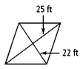
Find the area of the figures below.
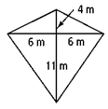
- 2. 3.

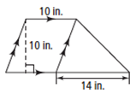
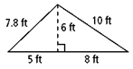
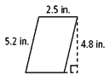
4. 5. 6.

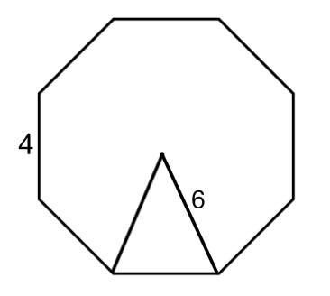
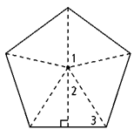
7. 8.
7.1

4.9

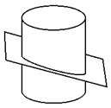
Draw the cross section of the figures below.
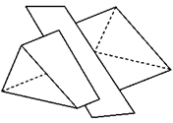
9. 10.

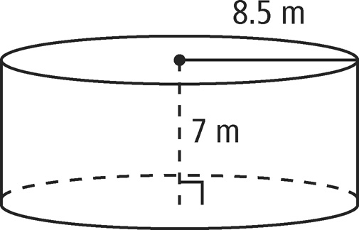
Find the volume, lateral area, and surface area of the solids below.
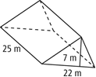
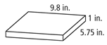
11. 12. 13.

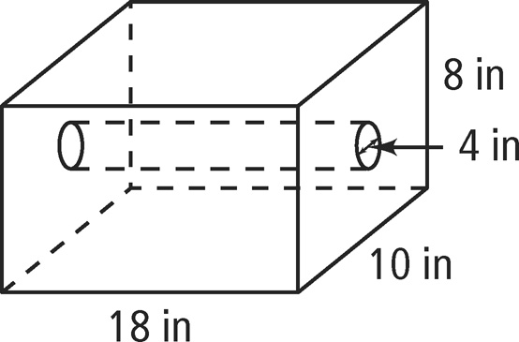
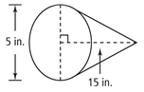
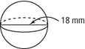
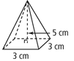
14. 15. 16. 17.

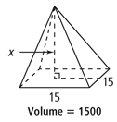
Find the value of x.
18. Volume: 602.88 cm³ 19.
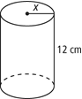

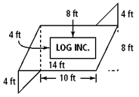
20. A company wants to paint its logo on the side of a building. The entire area needs to be covered with a primer. The two triangular areas will be painted red, the rectangle containing the company’s name will be white, and the rest of the parallelogram will be yellow.

21. An artist molds two different square pyramids out of clay. The first pyramid has a base edge of 8 cm and a height of 9 cm. The second pyramid has a base edge of 8.1 cm and a height of 8.5 cm. Which pyramid has the larger volume? How much more clay is required to make the larger pyramid?

22. A food company makes regular and tall soup cans. The area of the base of both cans is 5 cm². The volume of the regular can is 40 cm². The tall can is 2 cm taller. What is the volume of the tall can of soup?

23. Make sure you know your similar solid relationships!

