Unit 7 Test Review: Circles Name _________________________________________

- Add each of the following to the circle to the right. Be sure to label as directed.

- Center at the point J
- Radius $\overline{JB}$
- Diameter $\overline{LK}$
- Chord $\overline{KB}$
- Tangent $\overset{⃡}{LE}$
- Secant $\overset{⃡}{BL}$
- Central Angle $∠KJL$
- Inscribed Angle $∠BEK$

- Waffle house, Denny’s, Cracker Barrel and IHOP are competing for the Best Round Breakfast Award. (It is one of the highest honors of breakfast chains.) Both restaurants present their award-winning specialties to the judges, and the winning specialty will be decided based on the size of the round breakfast. The one with the largest area will win. Unfortunately, the judges measured different dimensions at each restaurant. Can you determine the winner?

Waffle House: A = 452in²

Denny’s: r = 23in

IHOP: d = 30 in

Cracker Barrel: C = 47 in

- You accidentally hit a baseball into your neighbor Peter’s yard. You want to get your ball back, but Peter has a very mean dog that will eat anything within a 5 meter radius of him. If your ball lands exactly 3.5 meters west and 3.5 meters north of the dog, will you be able to get your ball back, or will it be the dog’s afternoon snack?

- Given the circle with center C, complete the following.
  - Name 2 diameters _______
A
C
D
G
55°
H
K
E
F
80°
  - Name a chord which is not a diameter _____
  - Name a secant which is not a diameter _____
  - Name a tangent segment ______
  - $mAGF = ______$
  - $mAKG = ______$

  - $mGKH = _______$
  - $m \hat{DEG}= _________$
  - $m \hat{AEG}= _________$
  - $mKAG = ______$
  - $mKGF = ______$
- Name an arc congruent to $\hat{AEH}$ that is not identical to $\hat{AEH}$ _____________________

- Circle C has a diameter of 16 and $GF=6$, find the length of $CF$. ____________________

- What is the general equation of a circle?

- Write the standard equation of the circle below.
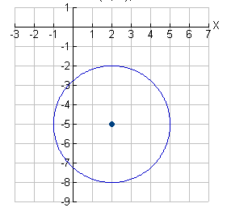
  - b. Center (2, 5) point on the circle (1, 3)

- Find the length of the darkened arc. 10. Given the arc length, find the
circumference of the circle.
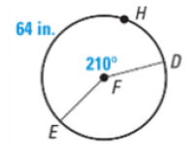
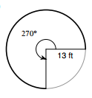

- Find the area of the sector ACB. 12. Find the area of the entire circle given the
area of the sector.
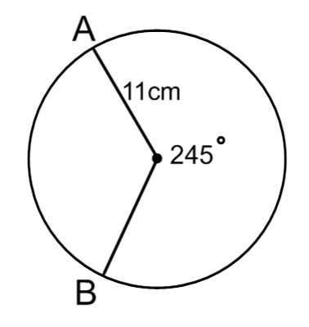
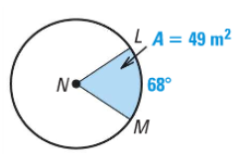

C

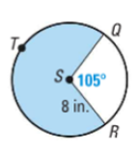
- Find the area of the shaded sector. Find the length of arc QTR

- Find the measure of the missing angles indicated below.
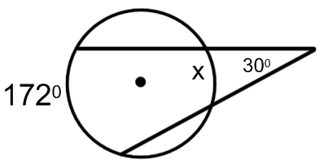
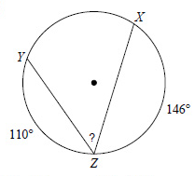
  - b.

$m∠YZX=__________$ $m\hat{x}=___________$

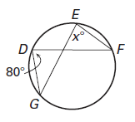
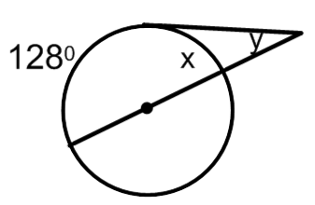
d. e.

$m∠GEF=___________$ $m\hat{x}=____$ $m∠y=$_______

f. g.
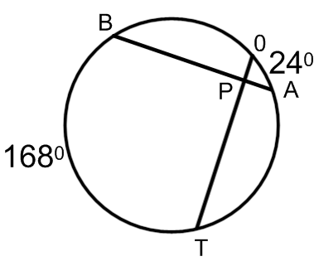
18º

200º

$m∠TPA=_______$ $m∠OPA= _______$ $m∠x=______$ $m∠y= ______$

