Name:________________
Triangle and Quadrilateral Properties Test Review
- Find the missing variables in the parallelogram
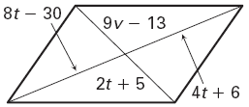
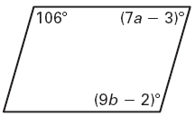

- Find the following for rhombus PQRS.
- $m∠QRT=$
- $m∠PTS=$
- $m∠QRS=$
- $m∠TSR=$
- $m∠PQR=$
4
- $m∠TQR=$
- $PR=$
- $QT=$
- $QS=$
- $RS=$

- Find the following using the kite.
- $m∠MTI=$
- $m∠KMI=$
- $m∠MKE=$
- $IT=$
- $KT=$
- $KE=$
- $ET=$
- Perimeter of kite KITE

- What quadrilaterals have all sides congruent?

- What quadrilaterals have opposite sides congruent?

- What quadrilaterals have opposite angles congruent?

- The diagonals of square DEFG intersect at H. Given that EH = 5, find the following.
- $m∠DHE=$
- $m∠EFG=$
- $m∠HGF=$
- $m∠GDH=$
- $GH=$
- $DF=$
- $DG=$
- $DE=$

- Find x in the following trapezoids.

- ABCD is an isosceles trapezoid. Find the following values.
- $m∠BCD=$
- $m∠BAD=$
- $x=$
- $AB=$
- $CD=$

- What quadrilaterals have perpendicular diagonals?

- What quadrilaterals have congruent diagonals?

- What quadrilaterals have diagonals that bisect each other?

- What properties do a square and rhombus share?

14. Identify the center of each triangle. You will use the following centers: Centroid, Circumcenter, Orthocenter, and Incenter.

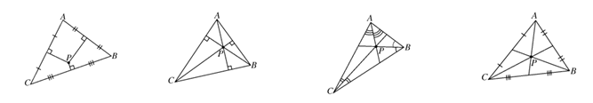

15. PW = 7, what is PV?
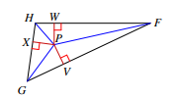

16. Given that two of the medians are shown and ZV = 12, what is EZ?
