Right Triangle & Trig Quiz Review Name: ____________________________

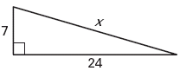
Find the missing side length. Write your answers in simplest radical form. Show all work!

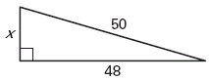

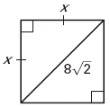

Simplify the following radicals
- A) $\sqrt{32}$ B)$\sqrt{45}$ C) $\sqrt{75}$

Determine whether the triangle below is a right triangle. Show all work.
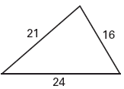

Tell whether the triangle is acute, obtuse, or right, show work.
- 5, 7, 9

- 16, 30, 34

- 18, 34, 45

- 25, 60, 65

Complete the table below for the following triangle.
x | 2 |  | 4 |  | 7
y |  | 2 |  | 2  3
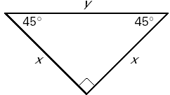

a | 5 |  |  | 6
b |  | 3  2
c |  |  | 8 |  | 22
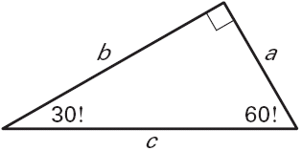

Find the missing lengths
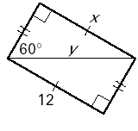
12.

