**Geometry Quiz Review Name:___________________**

**Congruent Triangles**

1. Identify if the pair of triangles drawn can be determined congruent by SSS, SAS, ASA, or AAS. If cannot be determined, explain why.

Can you determine congruent triangles? : Yes or No  
 **If yes**, write the congruence statement: __________

**If yes**, What postulate or theorem was used?_______________

**If no**, explain why not: ________________________________

__________________________________________

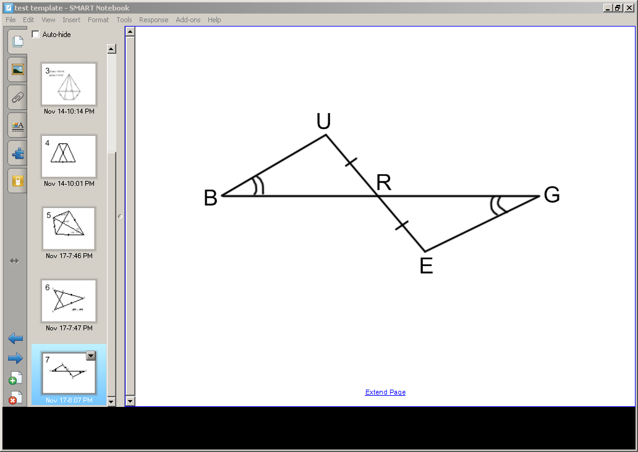

Can you determine congruent triangles? : Yes or No  
**If yes**, write the congruence statement: __________

**If yes**, What postulate or theorem was used?_______________

**If no**, explain why not: ________________________________

__________________________________________

2. An equilateral and an isosceles triangle share a common side. What is the measure of ?

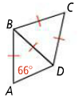

3. List all congruent sides and angles for the following triangles

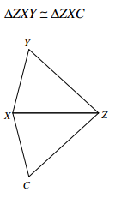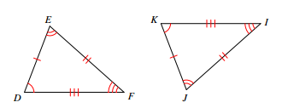

a. b.

4. Solve for x

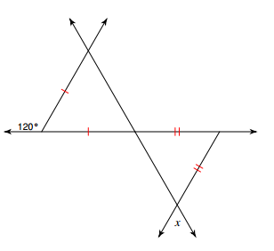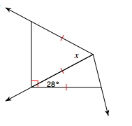

5. The two triangles are congruent. Find the missing values.

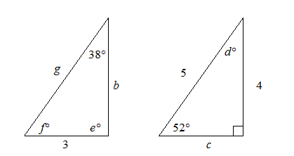

6. Which triangles are congruent by ASA?

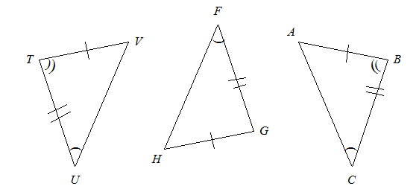

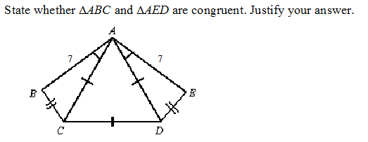7.

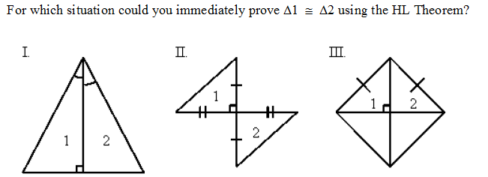8.