Name:____________________________

**Unit 3 Test Review: Triangle Congruency & Quadrilaterals**

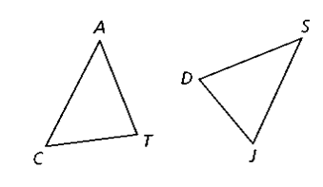

1. $∆CAT≅∆JSD$, list 3 pairs of congruent sides.

**List 3 pairs of congruent angles.**

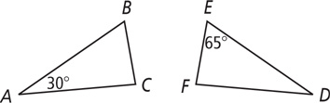

1. Given ∆*ABC* ≅ ∆*DEF, m*∠*A* = 30, and *m*∠*E* = 65, what is *m*∠*C?*

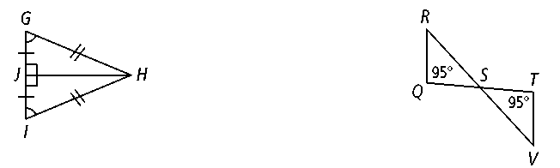

1. Write a congruent statement for the figure at the right.
2. For each figure below, determine whether the triangles are congruent by one of the shortcuts. If they are congruent, **WRITE THE CONGRUENCE STATEMENT**. If they are not congruent, explain why not.

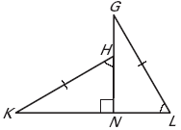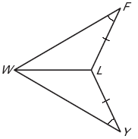

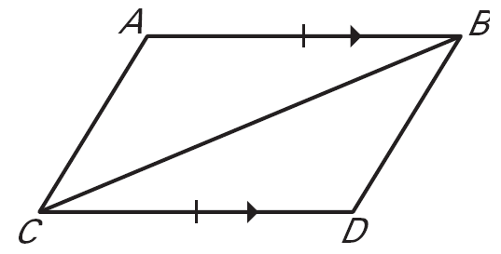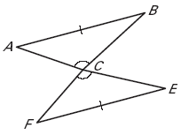

1. For each problem, determine what else must be congruent to prove the triangles congruent.
2. 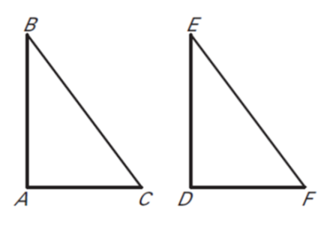
3. **Given: $\overline{AB}∥\overline{CD}$** , $\overline{AB}≅\overline{CD}$

**Prove: $∆ABC≅∆DCB$**

1. 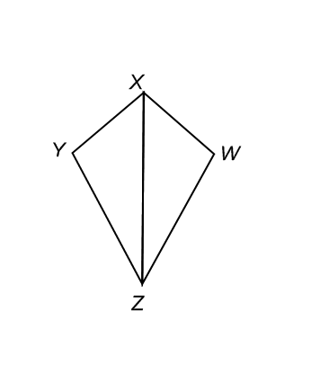**Given: $\overline{YX}≅\overline{WX}$, $\overline{ZX}$**  bisects $∠YXW$

**Prove: $∆XYZ≅∆WXZ$**

1. **Given: $\overline{RT}≅\overline{VT}$** , $∠RST≅∠VUT$

**Prove:** T is the midpoint of $\overline{SU}$

1. 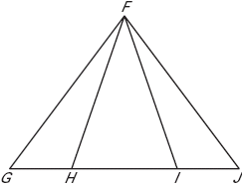 **Given: $\overline{HG}≅\overline{IJ}$** , $\overline{FG}≅\overline{FJ}$

**Prove: $\overline{HF}≅\overline{IF}$**

**Find the values of the missing variables.**

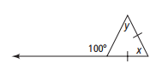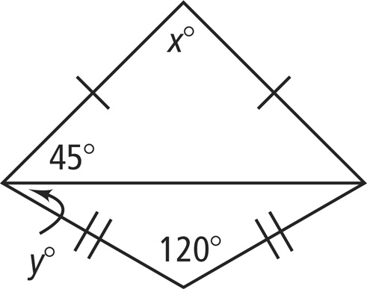

1. **12.**

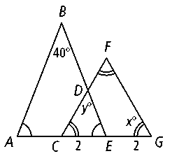

14. Determine the measure of the angles

*m*∠*ACB =*

*m*∠*DCE =*

*m*∠*BCD =*

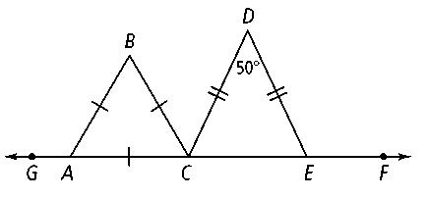

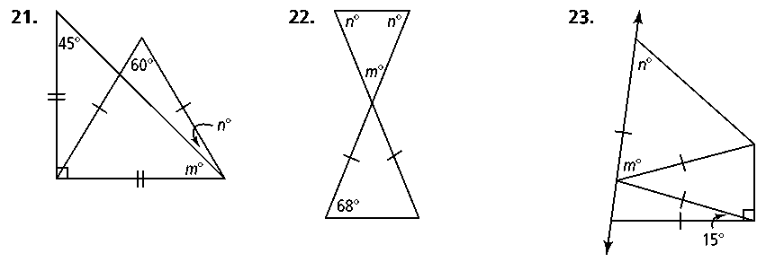

16. Find the missing variables in the parallelogram

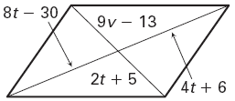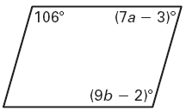

17. Find the following for rhombus *PQRS.*

1. 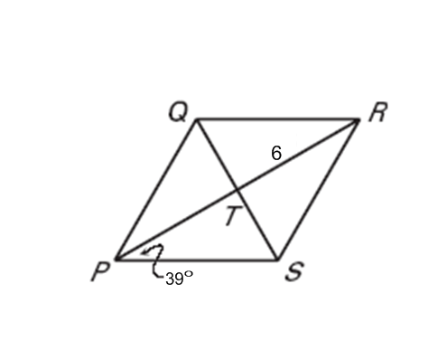

**4**

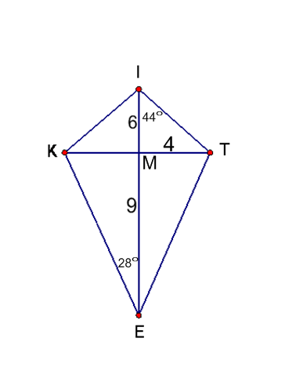

18. Find the following using the kite.

$m∠MTI=$

$m∠KMI=$

$m∠MKE=$

$IT=$

$KT=$

$KE=$

$ET=$

1. Perimeter of kite *KITE*

19. What quadrilaterals have all sides congruent?

20. What quadrilaterals have opposite sides congruent?

21. What quadrilaterals have opposite angles congruent?

22. The diagonals of square *DEFG* intersect at *H.* Given that *EH =* 5, find the following.

1. 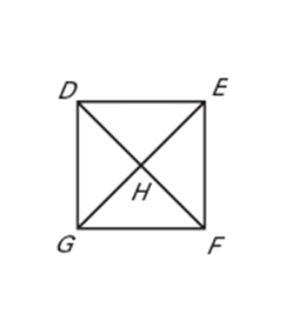

23. Find *x* in the following trapezoids.

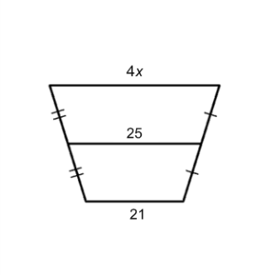

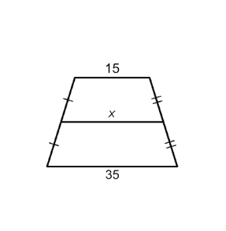

24*. ABCD* is an isosceles trapezoid. Find the following values.

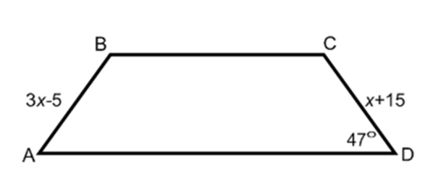

25. What quadrilaterals have perpendicular diagonals?

26. What quadrilaterals have congruent diagonals?

27. What quadrilaterals have diagonals that bisect each other?

28. What properties do a square and rhombus share?