**Geometry Name:___________________**

**Congruent Triangles Block:_________**

**Be sure to show all of your work. Unjustified Responses will not receive full credit.**

1) Given the figure,

$$2x+3$$

1

$$4x-7$$

$$113°$$

$$67°$$

2

(a) Find x = _________

(b) Find = _______

Find = _______

2) Find the values of the each numbered angle.

9

1

4

3

8

7

6

5

2

=_______

=_______

=_______

=_______

=_______

=_______

=_______

=_______

=_______

4) Identify if the pair of triangles drawn can be determined congruent by SSS, SAS, ASA, or AAS. If cannot be determined, explain why.

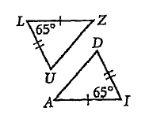

Can you determine congruent triangles? : Yes or No  
**If yes**, write the congruence statement: __________

**If yes**, What postulate or theorem was used?_______________

**If no**, explain why not: ________________________________

__________________________________________

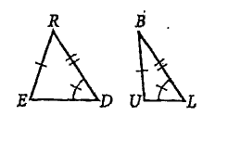

Can you determine congruent triangles? : Yes or No  
**If yes**, write the congruence statement: __________

**If yes**, What postulate or theorem was used?_______________

**If no**, explain why not: ________________________________

__________________________________________

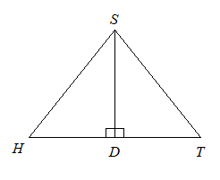 For the following problems, write a formal proof.

5) 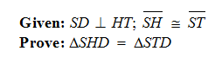



6) Given: and

Prove: 

7) List all congruent sides and angles of the triangle

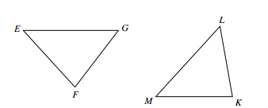

8) Find the missing values

B

6k

$$43°$$

n-3

C

D

x+2

E

9

m

12

z - 4

3y

7

F

A

$$101°$$

$$36°$$

k = ________ x = ________

m = ________ y = ________

n = ________ z = ________