Name:_____________________________
Unit 2 Test Review

1. Find the following information for the function $y=2x^{2}-15x+18$
- x-intercepts
- y-intercept
- axis of symmetry
- vertex
- two points that have the same y-value

2. If $g\left(x\right)=x^{2}-6x+8$ and (1,3) lies on the graph of g, but is not the vertex, what other ordered pair must lie on that graph?

3. It has been found that the formula for the stopping distance, C(v) of a car on a dry road in normal conditions is given by $C\left(v\right)=0.000208v^{2}+0.259v-0.0476$, where v is the speed in km/hr and stopping distance in meters.

a. What is the stopping distance when the car is travelling at 60 km/hr?

b. What is the maximum speed a driver can be travelling at if they see a traffic light change to red 30 meters in front of them?

It is apparent, however, that the stopping distance of a car is also related to the reaction time of the driver. It has been found that the reaction distance for the driver is given by $R\left(v\right)=0.00610v^{2}-0.0161v+0.238$, where v is speed in km/hr.

c. What is the reaction distance when the car is travelling at 60 km/hr?

The total stopping distance T(v) of a car is a combination the driver’s reaction distance R(v) and the car’s stopping distance C(v).

d. Write the new equation for T(v)

e. What is the total stopping distance when the car s travelling at 60 km/hr?

4. Solve for x

a. ${\left(\frac{1}{2}\right)}^{0.5x}=8$ b. $3^{-x}-1=5$ c. $1000{\left(1+\frac{0.008}{12}\right)}^{12x}=5000$

5. Find the following information for the function $y=-0.1x^{4}-0.7x^{3}+1.3x^{2}+6.5x-11$
- Find the zero(s)
- Find the y-intercepts
- Find the local maxima
- Find the local minima
- Find the intervals where the functions is increasing
- Find the intervals where the functions is decreasing

6. Find the following information for the function $y=\frac{3}{x-1}-2$
Horizontal Asymptote
- Vertical Asymptote
- Domain
- Range

7. Solve the following functions
a. $3^{x}=41$ b.$x^{0.5}+5=9$

8. A curve of the form $y=ax^{2}+bx+c$ is drawn and is shown below.
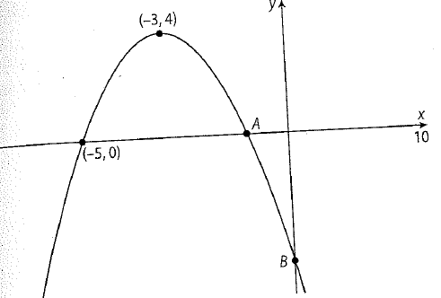

a. Find the coordinates of the point A. [2 marks]

b. Find the coordinates of the point B. [3 marks]

c. Write down the equation of the parabola. [1 mark]

9. A function is given by the equation $f\left(x\right)=35×{1.3}^{-0.5x}+20$.

a. Show that at $x=0, f\left(x\right)=55$. [2 marks]

The following table shows values for $x$ and $f(x)$.

$$x$$ | 1 | 2 | 3 | 4 | 5 | 6 | 8 | 10
$$f(x)$$ | 50.7 | 46.9 | 43.6 | 40.7 | p | 35.9 | 32.3 | q

b. Find the following information. [10 marks]
- Write down the values of p and q

- Draw the graph of $f(x)$ for $0≤x≤10$. Use a scale of 1 cm to present 1 on the horizontal axis and a scale of 1 cm to represent 10 on the vertical axis.
- Use your graph to find how long it takes for $f(x)$ to decrease to 39. Show your method clearly.
- Write down the horizontal asymptote. Justify your answer.

10. Vasili invest $25,000 in an account earning 5.75% simple interest for 3 years. At what annual interest rate would the same amount of money have to be earning monthly compound interest over 3 years?

11. Allessandro has three options for choosing a bank in which to invest his $3000. Which bank should he choose?
Bank A: 2.75% interest compounded monthly
Bank B: 3% interest compounded quarterly
Bank C: 3.25% interest compounded annually

12. William bought an apartment in 1985 for $117000 which appreciated at an annual rate of 5.4%.
a. Find the value of his apartment in 2008.

b. If William had instead invested his $117000 in a bank account earning 7% annual interest compounded monthly, but paid $350 per month in rent, would he have earned more or less money, and by how much?

