Name:__________________________
Trigonometry Test Review

Determine if the three sides form a triangle
- 7cm, 21 cm, 15 cm 2. 9 cm, 5 cm, 4 cm

- List the angles in order from largest 4. List the sides in order from largest
to smallest. to smallest.

Determine if the sides form an acute, right, or obtuse triangle
- 7cm, 25cm, and 24cm 6. 15cm, 13cm, and 4cm

10
26
45
x
y
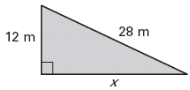
- 8.

9. Max needs to reach his cat, Fuzzy, who is stuck in a tree 12 feet above the ground. Max is a terrible tree climber so he will use a 16 foot ladder to get to Fuzzy the cat. How far away from the base of the tree should he place the bottom of the ladder so that he can reach Fuzzy?

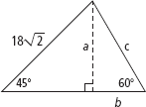
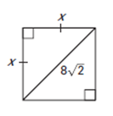
10. 11.

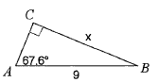
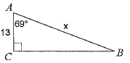
12. 13.

14. You are a block away from a skyscraper that is 780 feet tall. Your friend is between the skyscraper and yourself. The angle of elevation from your position to the top of the skyscraper is 42°. The angle of elevation from your friend’s position to the top of the skyscraper is 71°. To the nearest foot, how far are you from your friend?

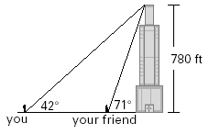

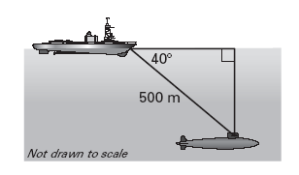
15. A sonar operator on a ship detects a submarine at a distance of 500 meters and an angle of depression of 40°. How deep is the submarine?

16. Find the missing sides and angles in the triangle to the right.

GH = ______________
GJ =______________
∠G =______________

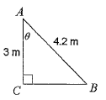
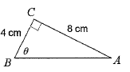
17. Find the missing angle, $θ$. 18. Find the missing angle, $θ$.

19. You lean a 20 foot ladder against a wall. The base of the ladder is 4 feet from the wall. What angle θ does the ladder make with the ground?

20. Find the missing sides and angles in the triangle to the right.
AC = ______________
∠A =______________
∠B =______________

21. Identify the center of each triangle. You will use the following centers: Centroid, Circumcenter, Orthocenter, and Incenter.
