Unit 2 Test Review

Find missing angle measures using what we know about vertical angles and linear pairs. THEN be able to say whether lines are parallel.

4. What is a linear pair?

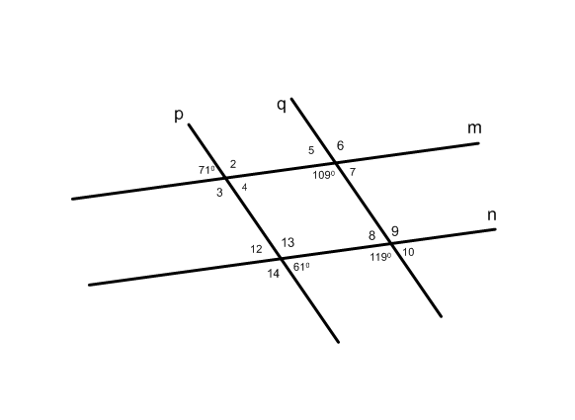
5. What are vertical angles?

6. Find the missing angle measures using vertical angles and linear pairs. Then determine which lines are parallel.

a) Are p and q parallel? yes no

Explain why.

b) Are m and n parallel? yes no

Explain why.

Find the value of x given parallel or perpendicular lines. You need to know which angles are congruent and supplementary.

7. If lines are parallel, which angle pairs are congruent?

a) Consecutive Interior b) Alternate Exterior c) Alternate Interior d) Corresponding

8. If lines are parallel, which angles pairs are supplementary?

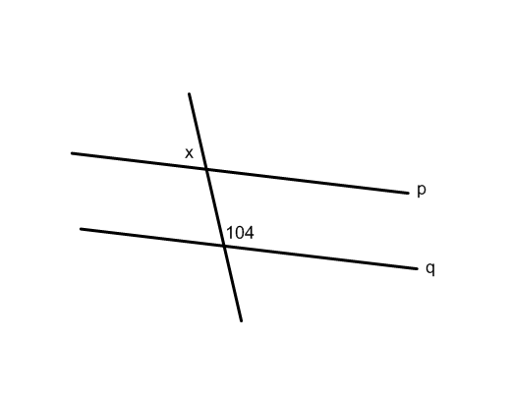
a) Consecutive Interior b) Alternate Exterior c) Alternate Interior d) Corresponding
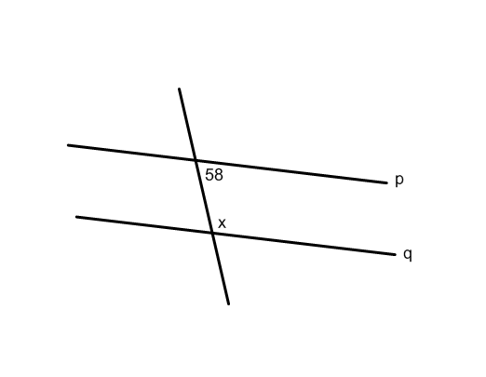
9. Find the value of x if p and q are parallel. Tell which theorem you used.

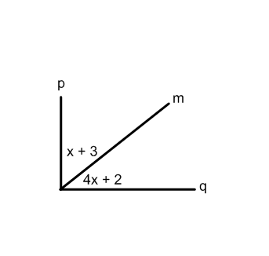
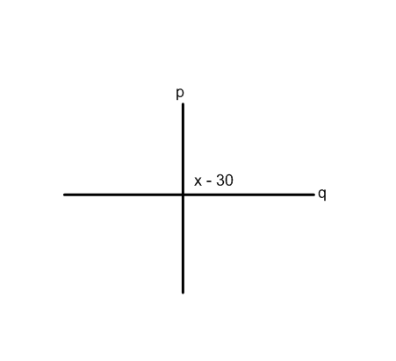

10. If p and q are perpendicular, find the value of x.

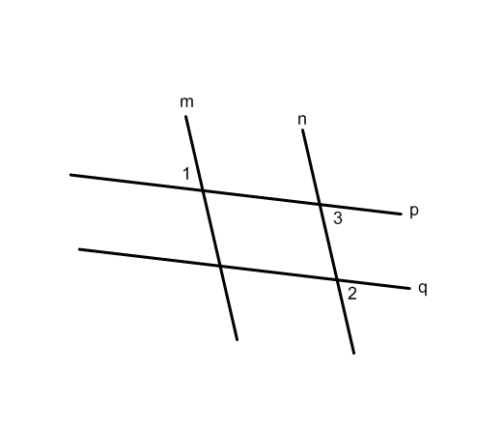
Use postulates and theorems about parallel lines to prove angles are congruent.

11. Given: $p∥q and m∥n$
Prove: $∠1≅∠2$

Statements Reason
1. $p∥q and m∥n$ 1.

2. $∠2≅∠3$ 2.

3. $∠3≅∠1$ 3.

4. $∠2≅∠1$ 4.

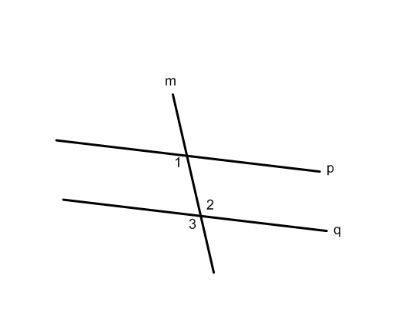
12. YOU MAY NOT USE THE ALTERNATE INTERIOR ANGLE THEORM IN THIS PROOF!!!

Given: $p∥q$
Prove: $∠1≅∠2$

Statements Reason
1. $p∥q$ 1.

2. $∠1≅∠3$ 2.

3. $∠2≅∠3$ 3.

4. $∠2≅∠1$ 4.

Name angle pair relationships.
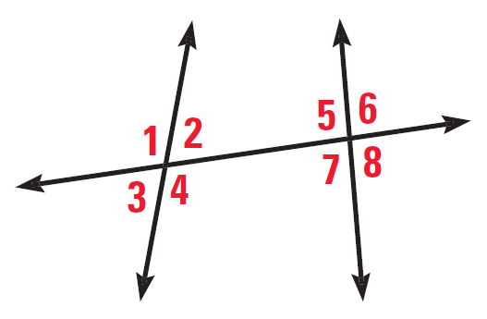
Given the figure to the right, name and angle that is:

13. Corresponding with 2.

14. Consecutive Interior with 4.

15. Alternate Exterior with 1.

16. Alternate interior with 5.

17. Vertical with 7.

18. Linear pair with 8.

Interpret diagrams

19. Determine if the statement can be assumed true from the diagram. Explain your reasoning.

$∠BAC$ and $∠CAD$ are supplementary.
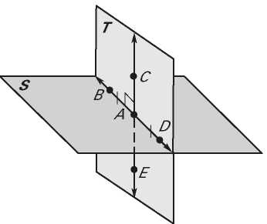
Plane S and plane T are perpendicular

A is the midpoint of $\overline{CE}$
$∠BAC≅∠EAD$
$\overset{⃡}{CE}⊥\overset{⃡}{BD}$
$\overset{⃡}{CE}$ bisects $\overline{BD}$

Explain statements about segments and angles.

20. Given: Line l bisects $\overline{DE}$ at point F
D is the midpoint of $\overline{CF}$
Explain why: $CD=FE$

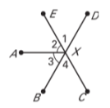
21. Given: $m∠2=m∠3 and m∠AXD=m∠AXC$
Explain why: $m∠1=m∠4$

Use parallel lines to find missing angles in a triangle. Apply the triangle sum theorem.

22. If $∠1=62°$ , $m∠5=31°$ and $\overset{⃡}{PR}∥\overset{⃡}{AC}$ find the missing angle measures.

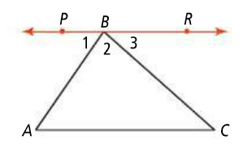
4
5

23. Write the converse, inverse, contrapositive for the following conditional statement. If the statement is false give a counterexample

Conditional Statement: If a square has 5-in. sides, then the square has area 25 in.²

Inverse:

Converse:

Contrapositive:

24. Write the biconditional statement for the conditional statement in #23. If you cannot write a biconditional statement, explain why.

For 25-26 use the law of detachment or law of syllogism to make a conclusion. If you cannot make a conclusion, explain why.

25. If you do not study, you will not get good grades. If you do not get good grades, you will not get into a good college.

26. All good tennis players are quick. Martina is a good tennis player.

27. Determine the property that was used

∠D ≅ ∠C and ∠E ≅ ∠C 4d = 16
∠D ≅ ∠E d = 4

28. Determine the next two terms in the pattern
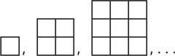
3, 6, 12, 24,…

KNOW ALL PARTS OF YOUR CONDITIONAL TABLE!

