**Similarity Test Review Name:**

1. Draw a triangle that satisfies this condition: The ratio of the interior angles is 7: 11 : 12. Find the measure of each angle.
2. For art class, you need to make a scale drawing of the Parthenon using the scale 1 in. is 5 ft. The Parthenon is 228 ft long. How long should you make the building in your scale drawing?
3. The measures of two complementary angles are in the ratio 7 : 11. What is the measure of the smaller angle?
4. The tenth grade at Milford High School has a dance every year. Last year there were 80 students in the tenth grade, and the party cost $200. This year there are 280 students in the tenth grade. How much should they plan to spend
5. Determine whether the triangles are similar. If so, write a similarity statement and name the postulate or theorem you used. If not, explain.

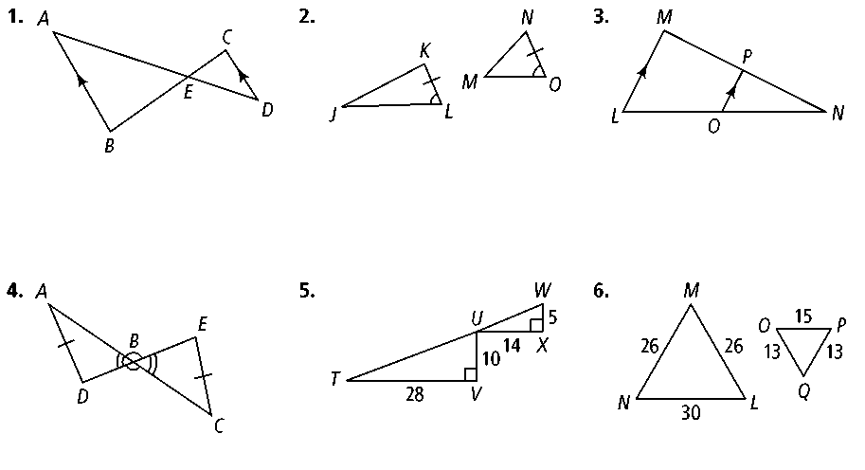**a) b)**

 **c) d)**

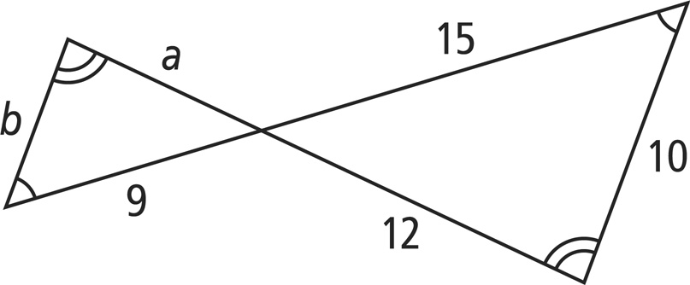**The polygons are similar. Find the value of each variable.**

|  |  |
| --- | --- |
| **6.** | **7.** |

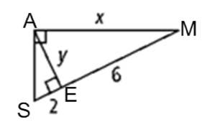Solve for the value of the variables in each set of similar right triangles.

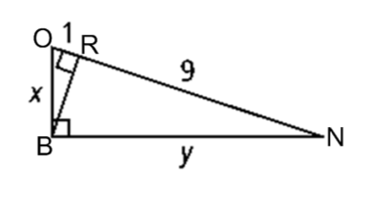8.

9.

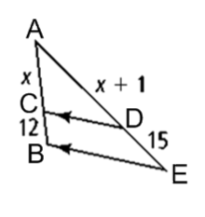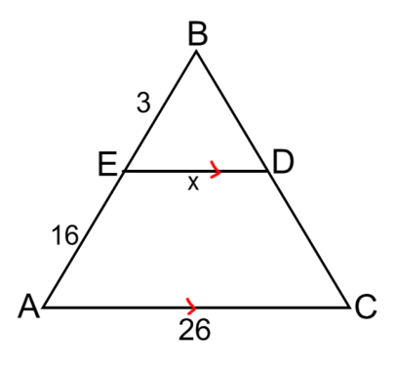Find the values of the missing variables.

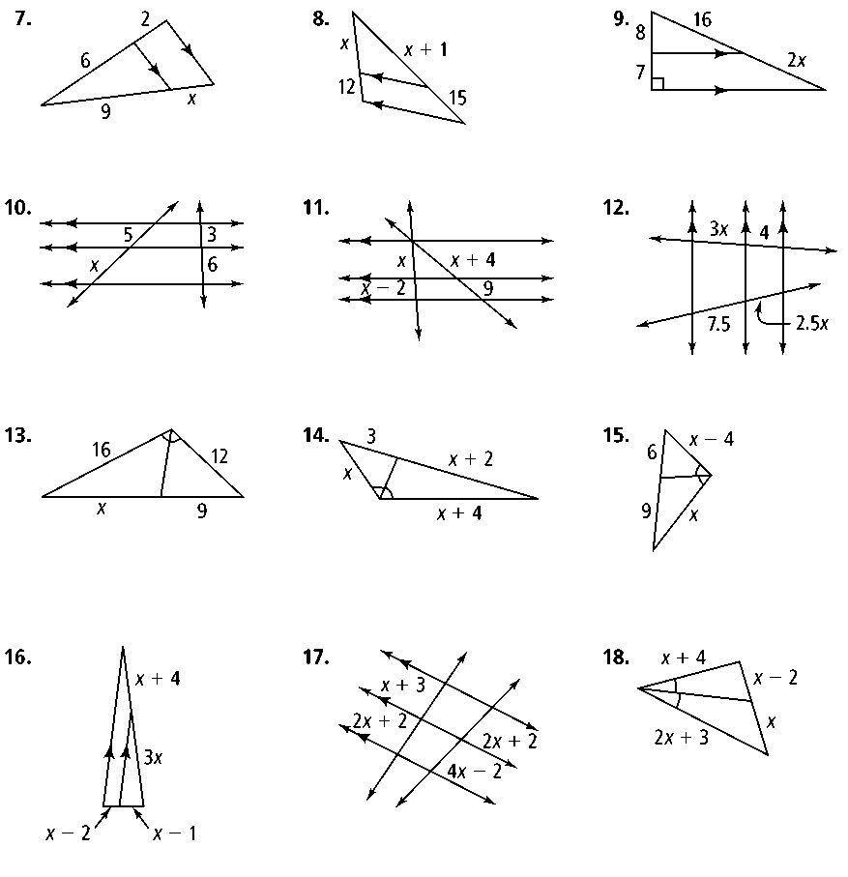10. 11. 12.

**In the diagram below,** ∆***NOP* ~** ∆***WXY .* Find each of the following.**

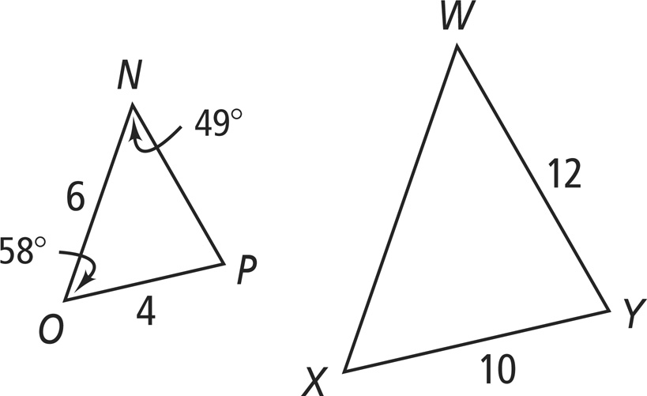13. scale factor of ∆*NOP* to ∆*WXY*

14. 

15. 

16. 

17. 

18. If ABCD ~ MSWI, find the scale factor and solve for ***x*** and ***y.***

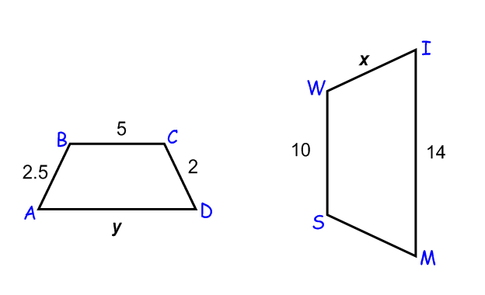

19. In the figures below, solve for the missing variables. Round to the nearest tenth as needed.

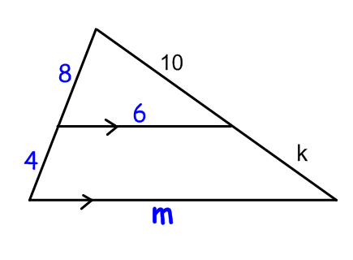

k = _________ m = __________

20. Explain why the two triangles are similar. Write a similarity statement and solve for ***x.***

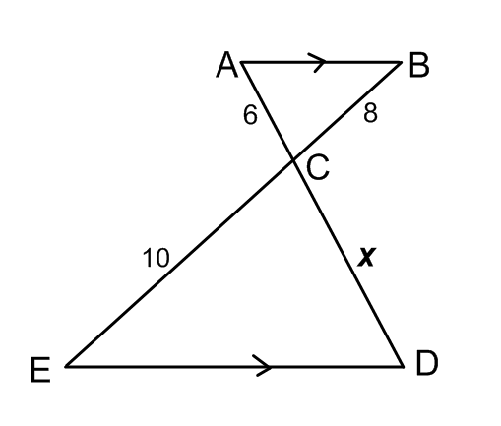

21. Mary retired from ornithology research to become an urban organic farmer and converted her rectangular back yard into a garden. The ratio of its length to its width is 5:2. If the garden has a ***perimeter*** of 112 feet, find the length and width.

22. 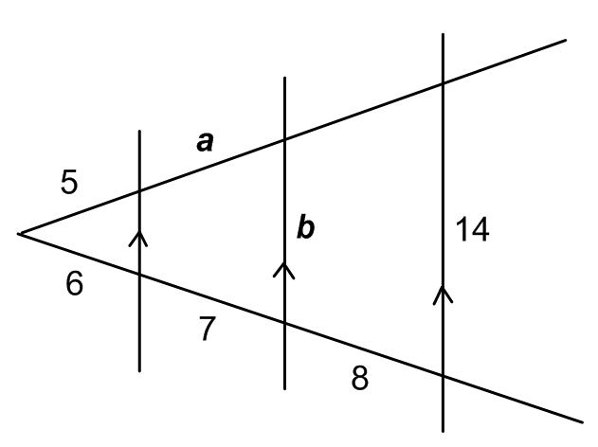Solve for the missing variables; round to the nearest hundredth when needed.