**Semester 1 Final Review Packet Name:_________________________**

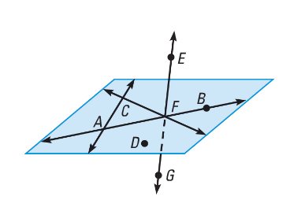**Unit 1: Intro to Geometry and Transformations**

1. Name 3 collinear points in the diagram.

***h***

1. Give another name for line *h*.
2. Give another name for $\overset{⃡}{EG}$.
3. Name the intersection of Plane ABC and $\overset{⃡}{EG}$.
4. Name a pair of vertical angles.
5. Name a linear pair.

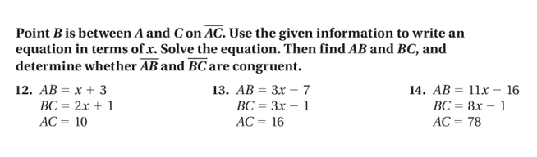

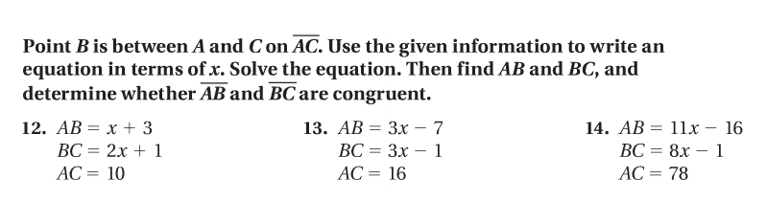

9.

8.

7.

1. $\overset{⃡}{AB}$ bisects $\overline{CD}$ at *E*. If *CE* = 3, find the length of $\overline{CD}$.
2. *R* is the midpoint of $\overline{ST}$. $RS=3x+10$ and $RT=x+23$. Find the length of $\overline{RT}$. Show your work and include a picture if helpful.

Find the coordinates of the midpoint of the segment with the given endpoints.

1. A(2, -4), B(7, 1) 13. C(-3, -2), D(-8, 4)
2. Maria wants to go to the circus Friday night. She knows the coordinates of her hour are (8, 3) and the coordinates of the circus are (-5, 6) using her GPS. What is the distance between the house and the circus? Show your work. Use the graph if necessary.

y

x

10

10

-10

-10

1. If Maria’s house has the coordinates (8, 3) and the halfway point between her house and the store has coordinates (5, 1), find the coordinates of the store (the other endpoint).
2. $m∠1=87°$ and is supplementary to $∠2$. Find the measure of $∠2$.
3. $m∠2=37°$ and is complementary to $∠3$. Find the measure of $∠3$.
4. Determine whether the angles are vertical, linear pair, or neither:

and  _____________

 and _______________

 and  _______________

 and  ______________

1. Translate the following pre-image on the graph below using the coordinate rule

     (x, y)   (x + 3, y – 2) and list the ordered pairs.





A’(      ,      )

B’(      ,      )

C’(      ,      )

1. Reflect the following pre-image on the graph below over the x-axis.  Fill in the blanks for the coordinate rule below the graph and the ordered pairs of the image.



A’(      ,      )

B’(      ,      )                             ( x, y) (               ,              )

C’(      ,      )

1. Rotate the figure the given number of degrees about the origin.  List the coordinates of the vertices of the image. The second graph is for you to plot your new image.



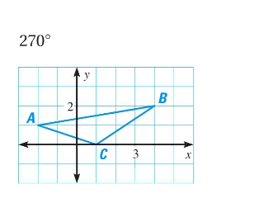

1. Find the coordinate of the indicated point after the **composition of transformations.**

**Transformation 1:** Reflection over the line $x=1$

**Transformation 2:** Translation using the coordinate rule

BA’ ___________               A’’ ____________

CB’ ___________               B’’ ____________

A

C’ ___________               C’’ ____________

**Unit 2: Logic and Parallel Lines**

1. Based on the pattern, what are the next two terms? What about the tenth term?

9, 15, 21, 27

1. Use the following conditional statement. **If your answer is FALSE, give a counterexample.**

If you in Florida, then you live in the south.

Converse:

Inverse:

Contrapositive:

Biconditional (State whether or not it is possible to write. If yes, write it. If no, explain why.)

1. Determine if you can make a conclusion. If yes, write it. If no, explain why.

If it is raining outside, then you are going to get wet

Susan is wet

1. Determine if you can make a conclusion. If yes, write it. If no, explain why.

If Johnny is in St. Louis, then he will go to a Cardinals baseball game.

If he goes to a Cardinals baseball game, then he will eat a hot dog.

1. Given: $∠2≅∠3$

Explain why $∠1≅∠4$

1. Find the slope of each line. Then determine whether they are parallel, perpendicular or neither.

**Line 1: (-3,-2), (1,2) Line 1: (6,6), (18,18)**

**Line 2: (1,3), (4,6) Line 2: (12,12), (0,24)**

**Circle:** *parallel, perpendicular or neither* **Circle:** *parallel, perpendicular or neither*

1. Name the angle that corresponds to the given angle.

$∠1 and __________$

$∠7 and __________$

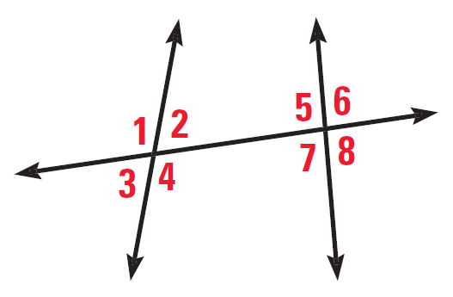

1. Name the angle that is an alternate interior angle to the given angle.
$∠2 and __________$

$∠5 and __________$

2. Name the angle that is an alternate exterior angle to the given angle.
$∠3 and __________$

$∠8 and __________$

3. Name the angle that is a consecutive interior angle to the given angle.
$∠5 and __________$

$∠7 and __________$

4. Name an angle that is a linear pair with $∠6. __________$
5. Name an angle that is a vertical angle with $∠4. __________$
6. Find the measure of all the angles below and state the theorem or postulate you used:



1 = _________________ Reason:

2 = _________________ Reason:

3 = _________________ Reason:

4 = __________________ Reason:

5 = __________________ Reason:

6 = __________________ Reason:

7 = __________________ Reason:

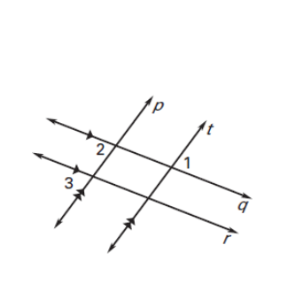

1. GIVEN: $q∥r and p∥t$

PROVE: 

Statements Reasons

1. q r, p t______________________
2.  ______________________
3.  ______________________
4. ______________________
5. 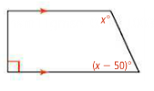Find the value of x. Explain your reasoning.
6. If $∠1=35°$, $m∠5=58°$, and $\overset{⃡}{PR}∥\overset{⃡}{AC}$  find the missing angle measures.



**Unit 3: Triangle Congruency:**

1. Determine whether the following pairs of triangles are congruent using one of the triangle congruence theorems (SSS, SAS, ASA, AAS). If they are congruent, **write the congruence statement.** If they are not congruent, **explain why**.
2. Find the measure of x in each diagram. Show all of your work.

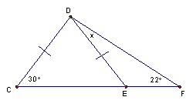

1.  Given: $\overline{AD}≅\overline{DC}$, *B* is the midpoint of $\overline{AC}$.

Prove: $∆ADB≅∆CDB$

1. Given: $\overline{AD}≅\overline{DC}$, $\overline{BD} bisects ∠D$.

Prove: $∠3≅∠4$

**Unit 4: Quadrilaterals:**

1. 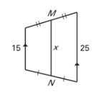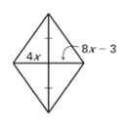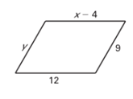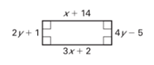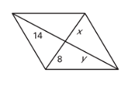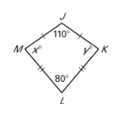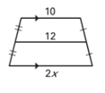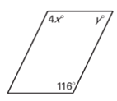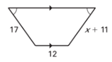Identify each figure and solve for the missing variables.
2. Find the degrees of each angle inside the regular polygons
   1. 5 sided polygon b. 8 sided polygon c. 12 sided polygon