Right Triangle & Trig Quiz Review Name: ____________________________

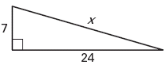Find the missing side length. Write your answers in *simplest radical form*. Show all work!

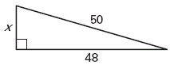

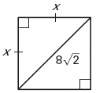

Simplify the following radicals

1. A) $\sqrt{32}$ B) $\sqrt{45}$ C) $\sqrt{75}$

Determine whether the triangle below is a right triangle. Show all work.

1. 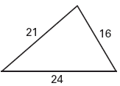

Tell whether the **triangle is acute, obtuse, or right, show work.**

1. 5, 7, 9
2. 16, 30, 34
3. 18, 34, 45
4. 25, 60, 65

Complete the table below for the following triangle.

|  |  |  |  |  |  |
| --- | --- | --- | --- | --- | --- |
| ***x*** | 2 |  | 4 |  | 7 |
| ***y*** |  | 2 |  | 2  3 |  |

1. 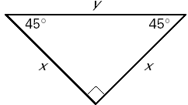

|  |  |  |  |  |  |
| --- | --- | --- | --- | --- | --- |
| ***a*** | 5 |  |  | 6 |  |
| ***b*** |  | 3  2 |  |  |  |
| ***c*** |  |  | 8 |  | 22 |

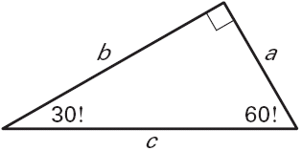

Find the missing lengths

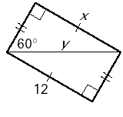12.