Name:_______________
Logic and Parallel Properties Quiz 2 Review

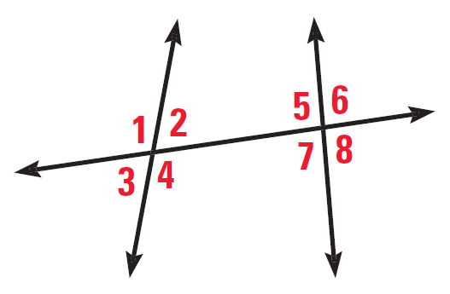
For problems 1-6 use the following diagram

1. Name all sets of corresponding angles

2. Name all sets of alternate interior angles

3. Name all sets of alternate exterior angles

4. Name all sets of same side interior angles

5. Name all sets of linear pairs

6. Name all sets of vertical angles

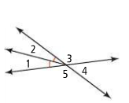
7. Name 3 true statements you can make from the diagram

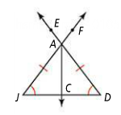
8. Name 3 true statements you can make from the diagram

For problems 9-12 solve for the missing angles. State which angle relationship you used to solve for each missing angle (ex. Corresponding, same side interior, alternate exterior, alternate interior, vertical, linear pair)
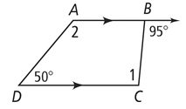
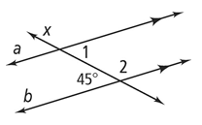
9. 10.

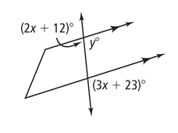
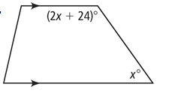
11. 12.

For problems 13-15 draw the description given

13. AB bisects DE 14. G is the midpoint of XZ

15. MN intersects LK and point R forming vertical angles. After drawing this, name the sets of vertical angles.

