Name:_____________________________
Unit 3: Math Models Test Review

1. A cottage is being constructed in an isolated location in the forest and the builder must use a narrow trail to carry all goods to the construction site. The builder is trying to determine how many hours it will take to shift 1000 bricks and he has constructed a table to calculate the length of time needed.

Hour | 0 | 1 | 2 | 3 | 4 | …
Number of bricks left to be moved | 1000 | 988 | 976 | 964 | 952 | …

a. Determine the gradient of the linear model

b. What is the equation that represents the linear model?

c. How many hours will it take for the 1000 bricks to be moved, assuming the builder continues at the rate?

After working for 12 hours the builder stops for the day.
d. How many bricks had the builder shifted at the time?

2. Find the following information for the function $y=2x^{2}-15x+18$
- x-intercepts
- y-intercept
- axis of symmetry
- vertex
- two points that have the same y-value

3. If $g\left(x\right)=x^{2}-6x+8$ and (1,3) lies on the graph of g, but is not the vertex, what other ordered pair must lie on that graph?

4. It has been found that the formula for the stopping distance, C(v) of a car on a dry road in normal conditions is given by $C\left(v\right)=0.000208v^{2}+0.259v-0.0476$, where v is the speed in km/hr and stopping distance in meters.

a. What is the stopping distance when the car is travelling at 60 km/hr?

b. What is the maximum speed a driver can be travelling at if they see a traffic light change to red 30 meters in front of them?

It is apparent, however, that the stopping distance of a car is also related to the reaction time of the driver. It has been found that the reaction distance for the driver is given by $R\left(v\right)=0.00610v^{2}-0.0161v+0.238$, where v is speed in km/hr.

c. What is the reaction distance when the car is travelling at 60 km/hr?

The total stopping distance T(v) of a car is a combination the driver’s reaction distance R(v) and the car’s stopping distance C(v).

d. Write the new equation for T(v)

e. What is the total stopping distance when the car s travelling at 60 km/hr?

5. Solve for x

a. ${\left(\frac{1}{2}\right)}^{0.5x}=8$ b. $3^{-x}-1=5$ c. $1000{\left(1+\frac{0.008}{12}\right)}^{12x}=5000$

6. Find the following information for the function $y=-0.1x^{4}-0.7x^{3}+1.3x^{2}+6.5x-11$
- Find the zero(s)
- Find the y-intercepts
- Find the local maxima
- Find the local minima
- Find the intervals where the functions is increasing
- Find the intervals where the functions is decreasing

7. Find the following information for the function $y=\frac{3}{x-1}-2$
Horizontal Asymptote
- Vertical Asymptote
- Domain
- Range

8. Solve the following functions
a. $3^{x}=41$ b.$x^{0.5}+5=9$

9. A curve of the form $y=ax^{2}+bx+c$ is drawn and is shown below.
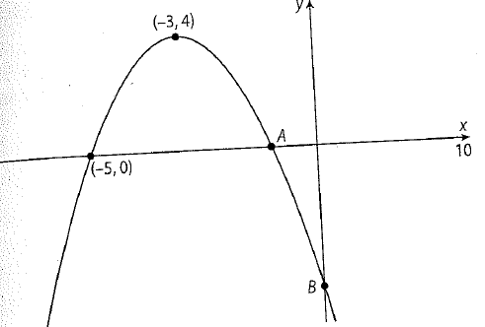

a. Find the coordinates of the point A. [2 marks]

b. Find the coordinates of the point B. [3 marks]

c. Write down the equation of the parabola. [1 mark]

10. A function is given by the equation $f\left(x\right)=35×{1.3}^{-0.5x}+20$.

a. Show that at $x=0, f\left(x\right)=55$. [2 marks]

The following table shows values for $x$ and $f(x)$.

$$x$$ | 1 | 2 | 3 | 4 | 5 | 6 | 8 | 10
$$f(x)$$ | 50.7 | 46.9 | 43.6 | 40.7 | p | 35.9 | 32.3 | q

b. Find the following information. [10 marks]
- Write down the values of p and q

- Draw the graph of $f(x)$ for $0≤x≤10$. Use a scale of 1 cm to present 1 on the horizontal axis and a scale of 1 cm to represent 10 on the vertical axis.
- Use your graph to find how long it takes for $f(x)$ to decrease to 39. Show your method clearly.
- Write down the horizontal asymptote. Justify your answer.

