Name:_______________________________
Unit 6: Geometry and Trigonometry Test Review

1. Hideaway is located at the point (5, 7) on the map. Find the gradient of the line from Hideaway to Mr. Horton’s house if Mr. Horton’s house is at the point (13, -9).

2. Write the equation of the line in gradient-intercept form.

3. What is the distance that Mr. Horton will have to travel to Hideaway?

4. Mr. Horton realized he doesn’t have enough gas to make it all the way to Hideaway. The gas station is halfway between his house and Hideaway. What coordinate on the map is the gas station located?

5. Find the equations that are parallel and perpendicular to the line in part a and go through the point (1, 1).

6. The width of a rectangular garden is given by the expression x + 3 yd. The length of the garden is 4 yd. Find the perimeter of the garden in terms of x.

7. Find the area of the garden in terms of x.

8. Given that the area and the perimeter are the same, find the length and the width of the garden.

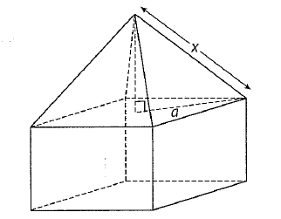
9. A square-based pyramid sits on top of a cube as shown.

a. Write down the height of the pyramid. [2 marks]

b. Determine the length of a. [2 marks]

c. Determine the length of x. [2 marks]

10. A drinking cup has been designed in the shape of a slanted cylinder as shown below.
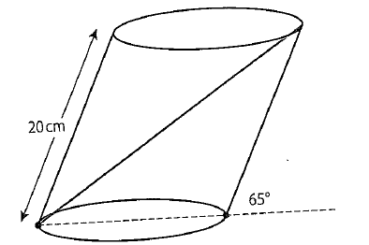

The diameter of the base is 12 cm and the slant height is 20 cm. What is the longest straw that will be required to go from top to bottom as shown in the diagram? [6 marks]

11. A triangular garden, ABC, has been constructed with BC = 17m, <ABC = 109º, and <CAB = 44º.
Note: Diagram is not drawn to scale.
B

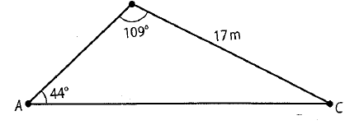

a. Calculate the length of AC, correct to two decimal places. [3 marks]

b. Write down the angle measure of <ACB. [1 mark]

The gardener wants to build a pathway from B to the point D which is halfway between A and C.

c. Calculate the length of the pathway from B to the midpoint of AC, correct to two decimal places. [5 marks]

d. Calculate the area of the triangle BDC, correct to two decimal places. [3 marks]

e. The fence around the triangle BDC is 20 cm high and the gardener intends to fill the area with soil. Find the volume of soil to be used, in cubic meters. [3 marks]

