HW: Sector Area Name:____________________

Use the image below to find the area of the following.
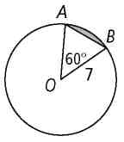
- O 2. AOB

- sector AOB 4. the shaded segment

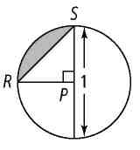
- P 6. RPS

- sector RPS 8. the shaded segment

