HW: Similar Solids Name: ____________________________________

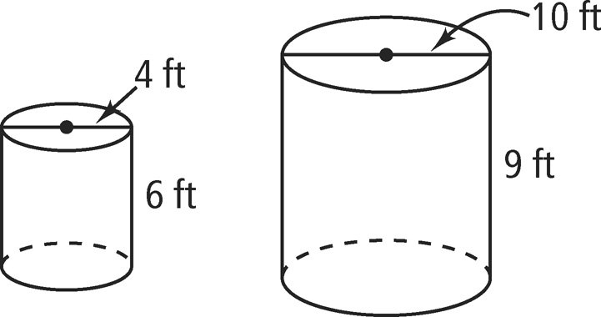
Determine if the two figures are similar. If so, give the scale factor of the first figure to the second.
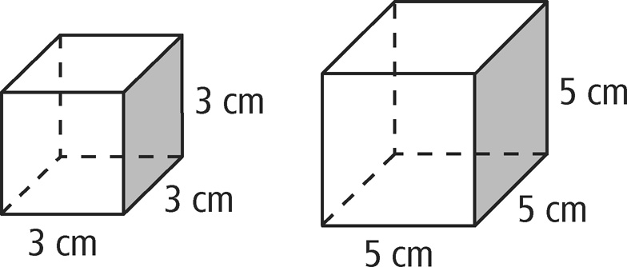
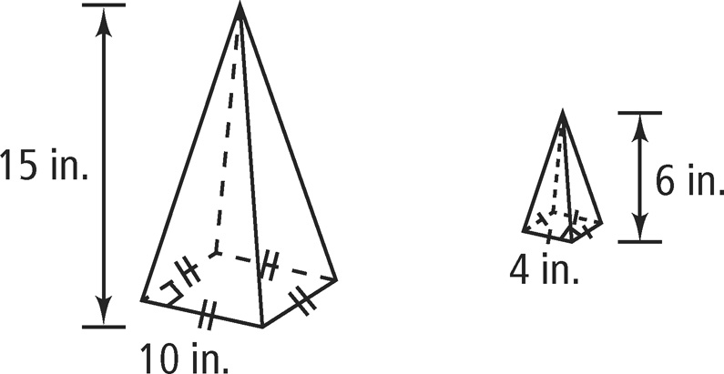
1. 2. 3.

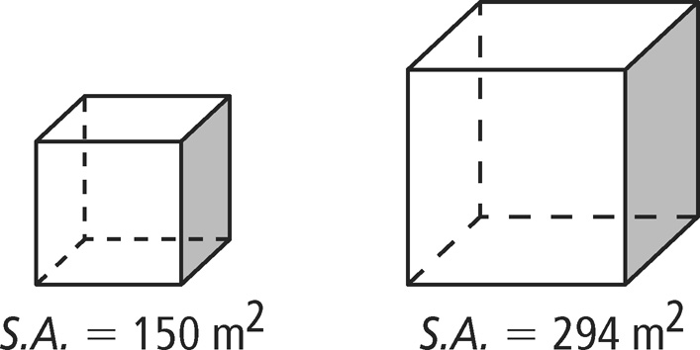
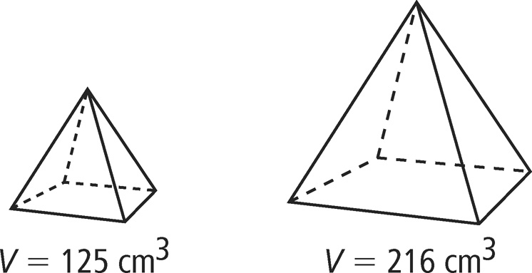
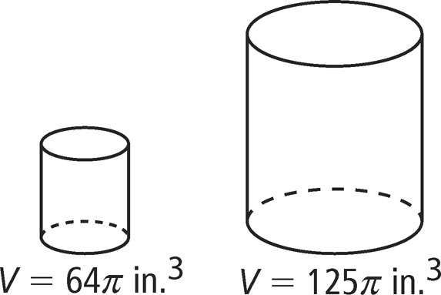
Each pair of figures is similar. Use the given information to find the scale factor of the smaller figure to the larger figure.
4. 5. 6.

Fill in the tables below with the missing information about two similar figures.
7. | S.A. | V.
Smaller Figure | 36m²
Larger Figure | 225m² | 750m³
8. | S.A. | V.
Smaller Figure | 36m² | 8m³
Larger Figure |  | 27m³

