Volume Practice Name:___________________________

Find the volume of each figure:
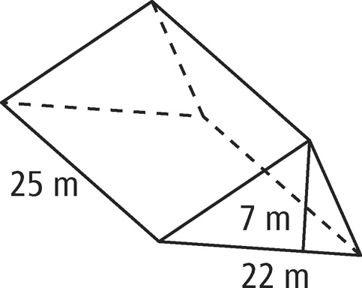
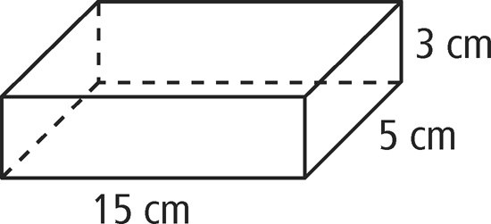
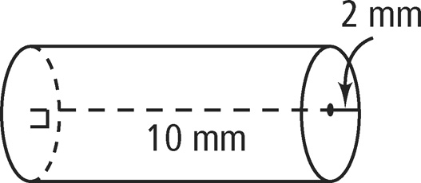
1. 2. 3.

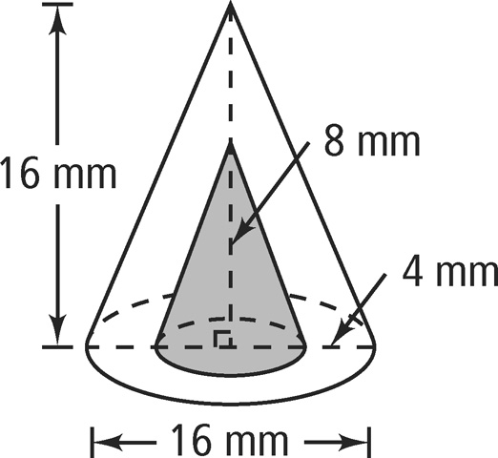
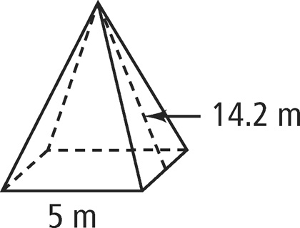
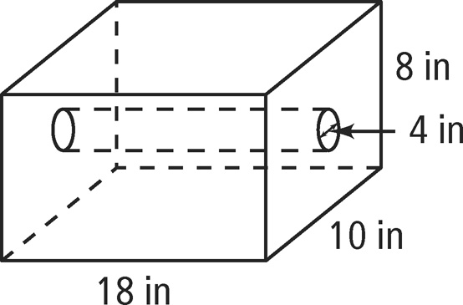
4. 5. 6.

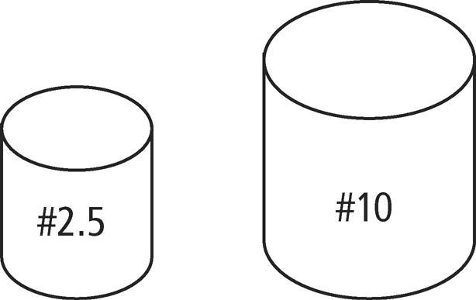
7. A No. 10 can has a diameter of 15.5 cm and a height of 17.5 cm. A No. 2.5 can has a diameter of 9.8 cm and a height of 11 cm. What is the difference in volume of the two can types, to the nearest cubic centimeter?

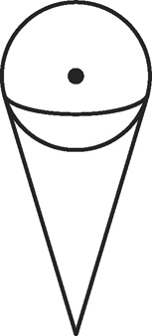
8. A spherical scoop of ice cream with a diameter of 4 cm rests on top of a sugar cone that is 10 cm deep and has a diameter of 4 cm. If all of the ice cream melts into the cone, what percent of the cone will be filled?

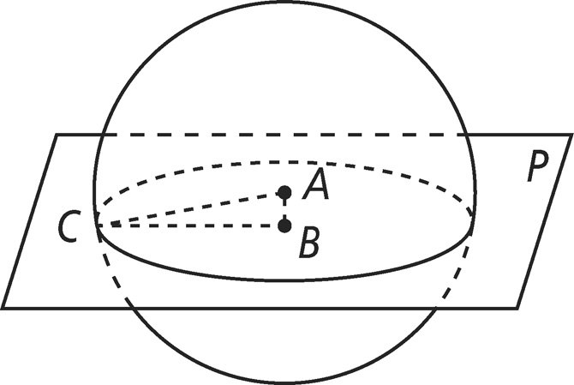
9. Point A is the center of the sphere. Point C is on the surface of the sphere. Point B is the center of the circle that lies in plane P and includes point C. The radius of the circle is 12 mm. AB = 5 mm. What is the volume of the sphere to the nearest cubic mm?

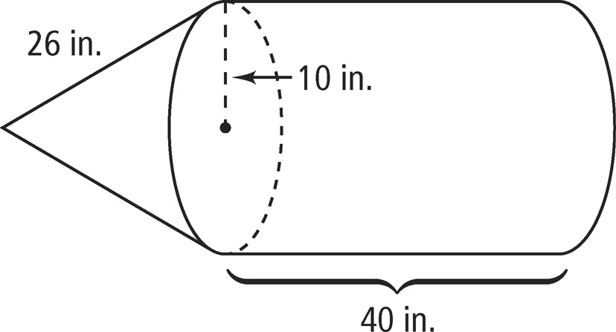
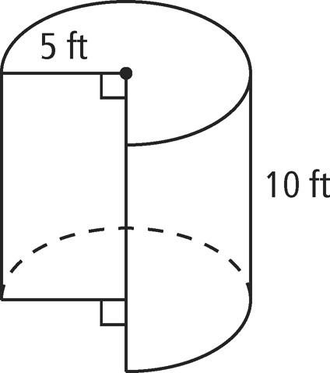
10.
11.

12.

