HW: Equations of Circles Name:_______________________

Find the center and radius of each circle

1. x² + y² = 36 2. (x − 2)² + (y − 7)² = 49

3. (x + 1)² + (y + 6)² = 16 4. (x + 3)² + (y − 11)² = 12

Write the standard equation of each circle

5. center (0, 0); r = 7 6. center (4, 3); r = 8 7. center (5, 3); r = 2

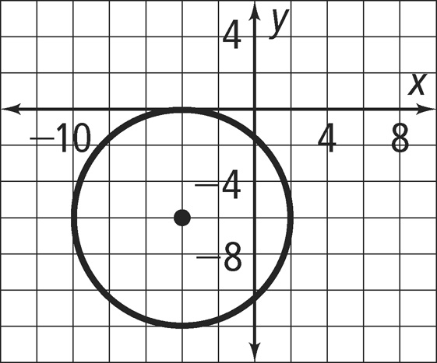
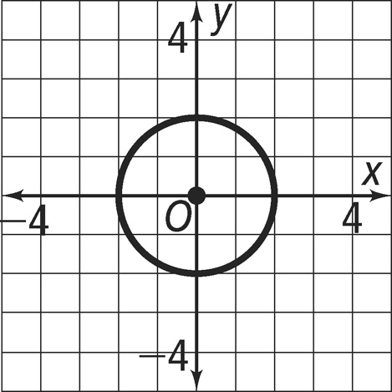
8. 9.

10. Write the standard equation of the circle with the given center that passes through the agfadfdafgiven point

center (5, 9); point (2, 9)

