HW: Midsegment of Triangles and Trapezoids Name:_________________

Find the value of $\overline{XY}$.

- 2.
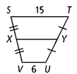
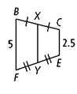

Solve for $x$ and then find the lengths of BOTH bases AND the midsegment.

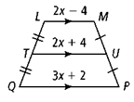
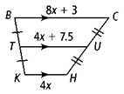
3. 4.

Find the value of $x$ and then find the length of that side.
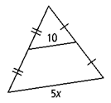
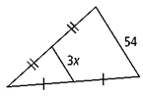
5. 6.

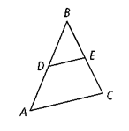
Use the picture to the right to answer problems 7-10.

7. If m∠A = 60, find m∠BDE.

8. If m∠BED = 83, find m∠C.

9. If DE = 13, find AC.

10. If AC = 73, find DE.

