HW: Classifying Triangles (5.6 & 5.7) Name ______________________________
1. List the angles of each triangle in order from smallest to largest.
A. B.

2. Can a triangle have sides with the given lengths? Explain.

A. 8 cm, 7 cm, 9 cm

B. 7 ft, 13 ft, 6 ft

3. The lengths of two sides of a triangle are given. Describe the possible lengths for the third side.
A. 5, 11

B. 12, 12

4. Determine whether the triangle with the following side lengths is acute, obtuse, or right.

- $3, 9, and 3\sqrt{11}$

- $11, 25, and 27$

- $32, 60, and 68$

5. Find the range of possible values that x can be.
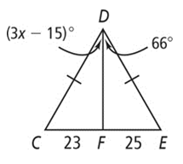
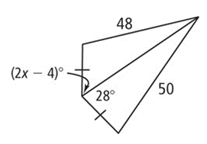
A. B.

