Name:__________________________

Function Composition Homework

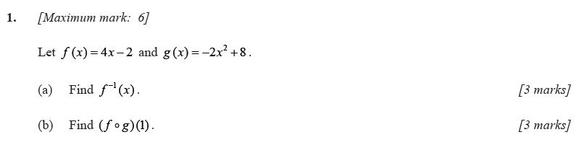

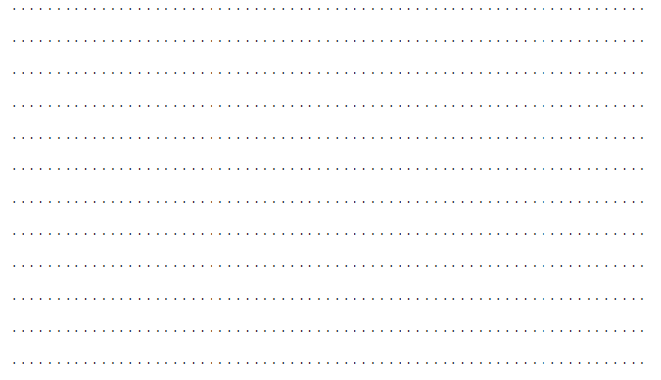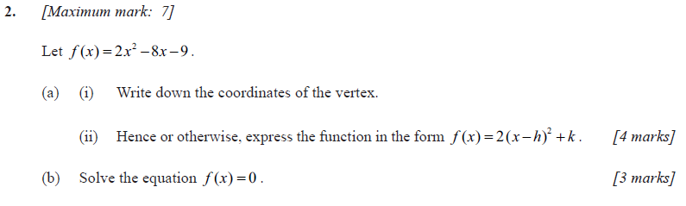

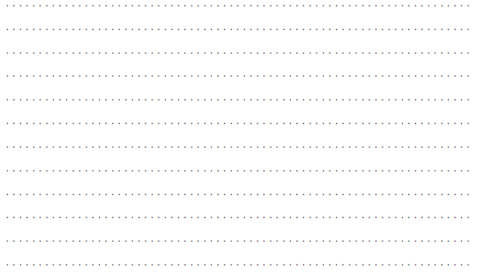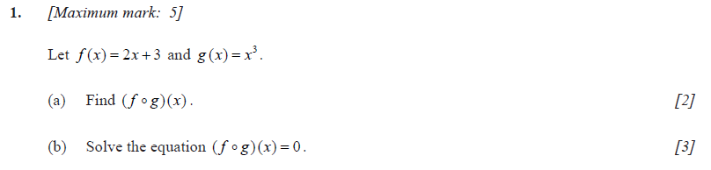

**3.**

