Isosceles and Equilateral Triangle Practice Name:________________________________

1. Use the diagram to complete each statement.
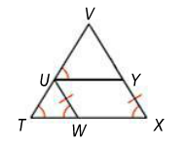
a. $\overline{VT}≅ _______$

b. $\overline{UT}≅ _______≅\overline{YX}$

c. $\overline{VU}≅ _______$

d. $∠VYU≅ __________$

2. Find the values of x and y.
a. b.

3. Find the measure of the indicated angle.

a. $m∠ACB=_________________$ b. $m∠ABC=_________________$

5. Find the values of m and n.

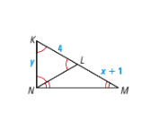

5. Find the values of x and y.

a. b.

