Name:________________________
Simplifying Square Roots

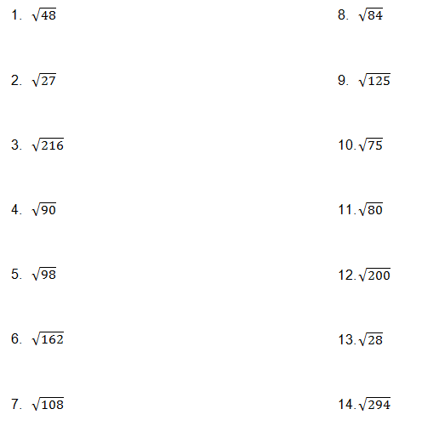

15. $\sqrt[3]{8}$ 16. $\sqrt[3]{243}$

17. $\sqrt[4]{16}$ 18. $\sqrt[4]{32}$

