Name:____________________
Homework: Arc Measures (7.4)

Find the missing measures of the variables
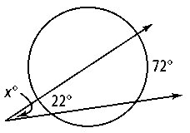
1. 2.

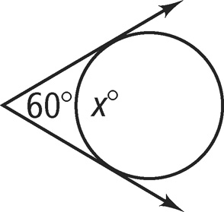
3. 4.

5. Find the measure of each arc in B.


   