Name:___________________________
Geometric Series and Sequence Homework

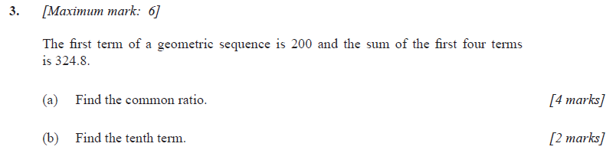
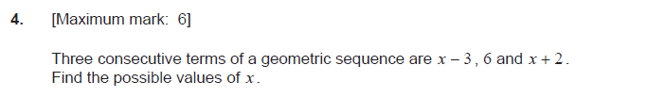

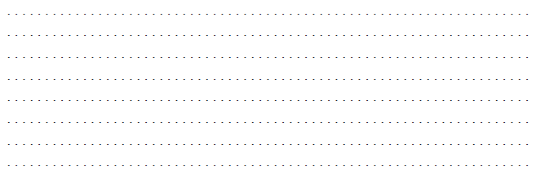
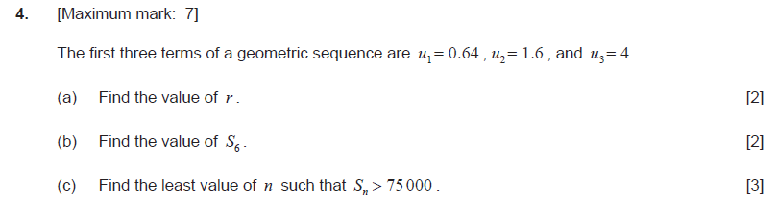
5.

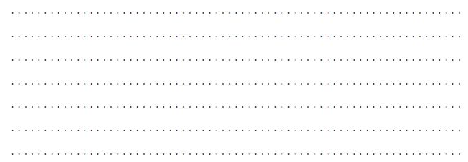
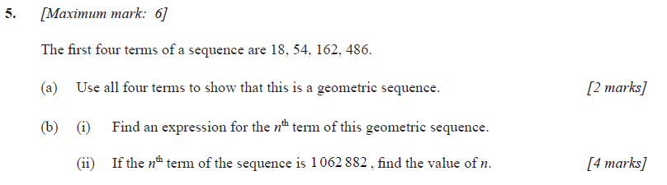
6.

