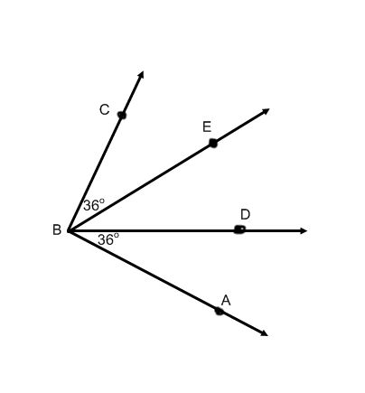

1. Explain why $m∠CBD≅m∠EBA$. Be specific
2. Why is the perimeter triangle ADC the same as triangle ABC?

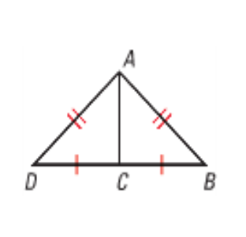

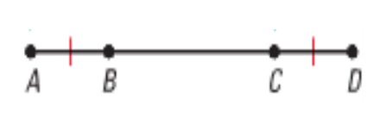

1. Explain in words: Why is $\overline{AC}≅ \overline{BD}$
2. Given: $m∠1=m∠3 and m∠2=m∠4$

Prove: $m∠ABC=m∠DEF$

1. Given: ∠1 and ∠5 are supplementary

∠3 and ∠5 are supplementary

Prove: ∠1 $≅$ ∠3

1. Given: ∠3 is supplementary to ∠1

∠4 is supplementary to ∠2

Prove: ∠3 $≅$ ∠4



1. Given: m∠4 + m∠6 = 180

Prove: m∠5 = m∠6

1.  Given: RT and PQ intersecting at S,

so that RS = PS and ST = SQ

Prove: RT = PQ



1. Given: $OA$ $⊥$ OC

Prove: ∠AOB and ∠BOC are complementary angles

1. Given: AC $⊥$ BC; ∠3 is complementary to ∠1

Prove: ∠3 $≅$ ∠2

1. Given: AO $⊥$ CO

Prove: ∠1 and ∠3 are complementary angles

For problems 12-17: You are asked to prove 6 theorems about parallel lines. To complete these proofs you may **NOT** use the theorem you’re trying to prove as a reason. One of these proofs will be on your Unit Test.

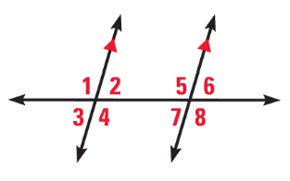







12. Given: 

Prove: 









13. Given: 

Prove: 

14. Given: 









Prove:  are supplementary









15. Given: 

Prove: 









16. Given: 

Prove: 

17. Given:  are supplementary









Prove: 



18. Given: DC BD; ∠1 ∠2

Prove: BA BD



19. Given: *BC = AB*  
Prove: *AB* = **