Name:__________________
HW: Quadrilateral Practice

1. Describe two ways that you can tell whether or not a parallelogram is a rectangle.

2. In order to say that a rhombus is a square, what must be true?

3. If the diagonals of a quadrilateral are perpendicular, can it be a rectangle? Explain.

Problems 4-5 solve for the indicated variables and determine the shape of each quadrilateral

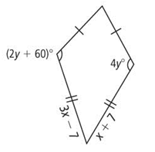
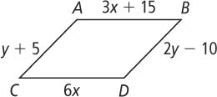
4. 5.

6. Solve for the missing angles
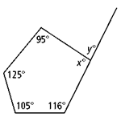
7. Determine the diagonal lengths of the parallelogram

8. Solve for the missing variables. Determine the shape of the quadrilateral
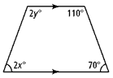

For problems 9-11, determine if there is enough information to conclude that the indicated shape is true. Explain why or why not.
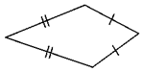
9. Kite
Yes No

Why:__________________________________

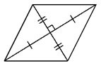
10. Square
Yes No

Why:___________________________________

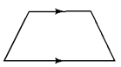
11. Isosceles Trapezoid
Yes No

Why:____________________________________

