HW: Calculating Area & Perimeter Name: ____________________________________

Find the area of each trapezoid.
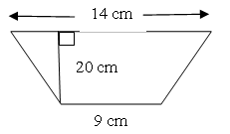
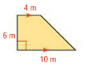
- 2.

3. Find the area of the rhombus. 4. Find the area of the parallelogram.
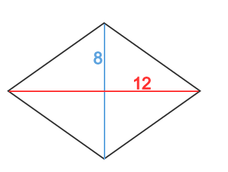
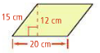

5. The border of Tennessee resembles a trapezoid with bases 340 mi and 440 mi and height 110 mi. Estimate the area of Tennessee by finding the area of the trapezoid.

6. Find the perimeter of the following shapes:
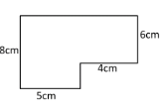
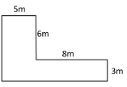
a: b:

