HW: Congruent Figures Name:_______________________________________

- If $WXYZ≅JKLM$, then list the following:
- Four pairs of congruent sides

- Four pairs of congruent angles

- For each figure below, can you conclude the triangles are congruent? If they are congruent, list the congruent theorem. If not, explain your reasoning.
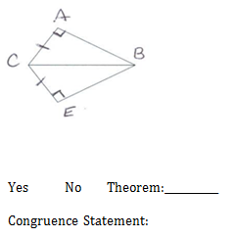
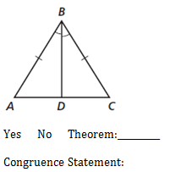
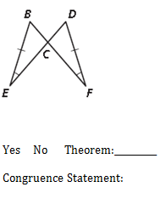

- $∆ABC≅∆DEF$. Find the measure of BC and EF if $BC=3z+2$ and $EF=z+6$.

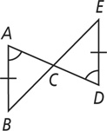
- Given: $\overline{AD} and \overline{BE} bisect each other$
$\overline{AB}≅\overline{DE}$, $∠A≅∠D$

Prove: $∆ACB≅∆DCE$

Statements Reasons

- $\overline{AD} and \overline{BE} bisect each other$ 1.
$\overline{AB}≅\overline{DE}$, $∠A≅∠D$

- $\overline{AC}≅\overline{CE}$ and $\overline{BC}≅\overline{CE}$ 2.

- $∠ACB≅∠DED$ 3.

- $∠B≅∠E$ 4.

- $∆ACB≅∆DCE$ 5.
- Find the value of the x in the figure below:
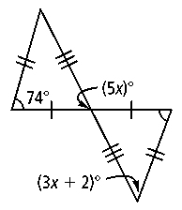

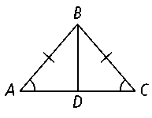
- Given: $\overline{BD}$ is the angle bisector of $∠ABC$
$\overline{BD}$ is the perpendicular bisector of $\overline{AC}$

Prove: $∆ADB≅∆CDB$

