Name:____________________________

Arithmetic Series and Sequences Homework

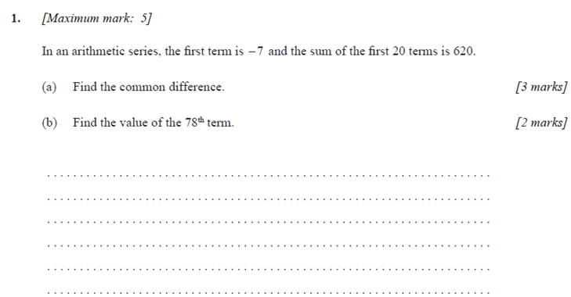

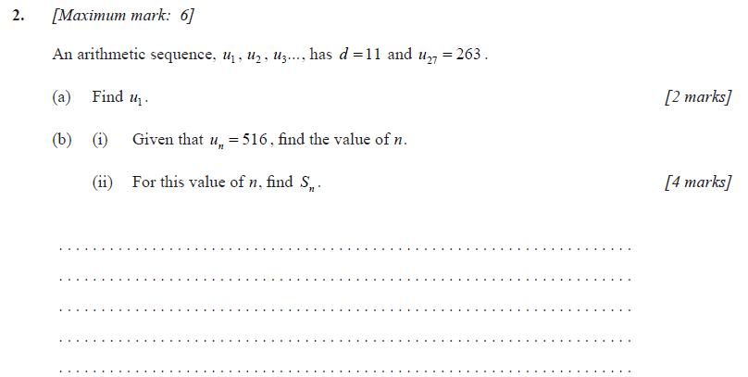

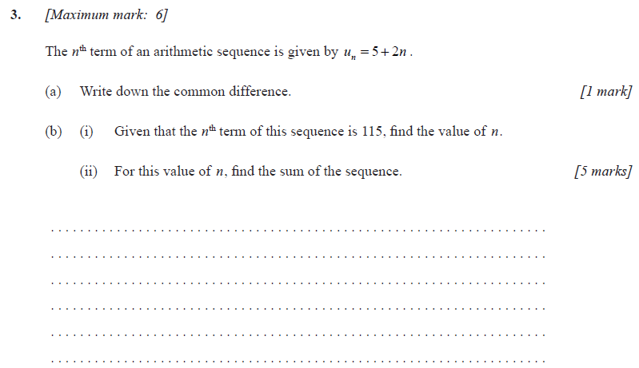

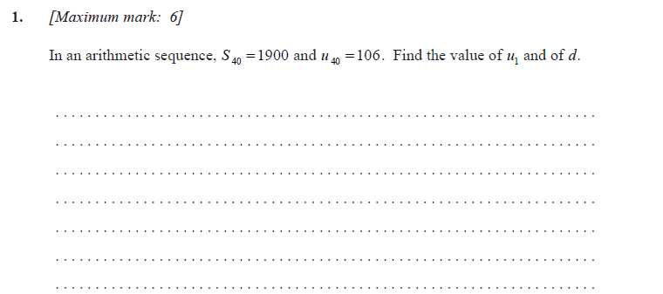

**4.**

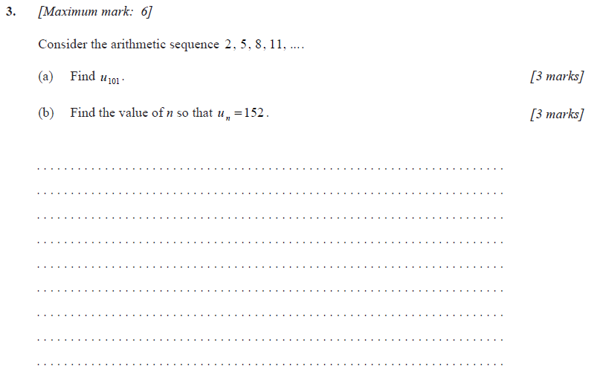

**5.**