Name: ____________________
Block: __________
Circles Quiz Retake

Be sure to show all of your work. Unjustified responses will not receive full credit.

Given the circle with center, G, identify/find the following parts:
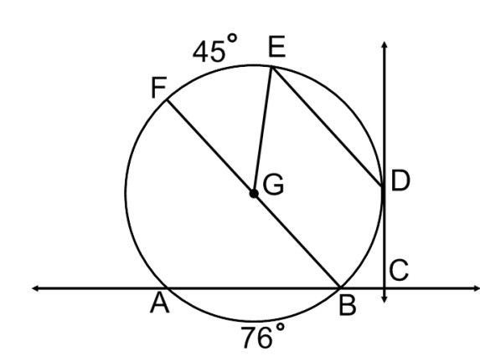
- Name the diameter. ___________

- Name a chord that is not a diameter. _____________

- Name a tangent segment. ____________

- Name a secant. ____________

- Name a radius. ____________

- $m∠FGE$ ___________

- $m\hat{FAB}$ ___________

- $m\hat{FA}$ ___________

- $m∠FBA$ ___________

- $m\hat{BDE}$ ______________

- $m∠FGB$ ____________

Find the indicated measure in the problems below.
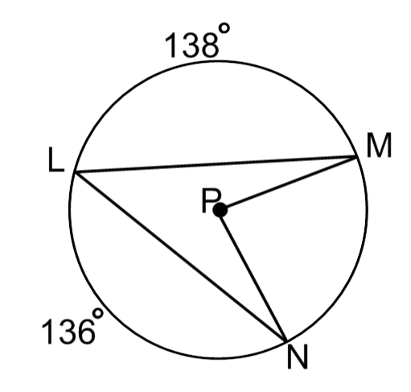
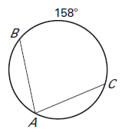
12) 13)

$m∠MPN$ = _____________

$m∠MLN$ = _____________

$m∠BAC=__________$

- If $\overline{RQ}$ is a tangent segment to circle P and $\overline{PR}$ is the radius of the circle, find the lengths PQ and SQ. Show all work.

PQ = _________ SQ = ___________ Work:
R
S
Q

Find the indicated measures.
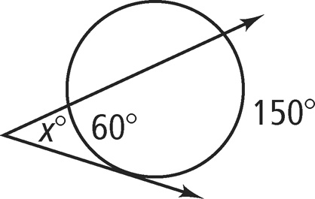
15. 16. 17.

x = _________ x = ____________ $m∠Y=____$_ $m\hat{x}=_____$

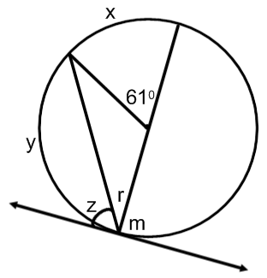

18. Use the diagram to find the measures of the indicated arcs and angles.
$x=$___________

$y=$___________

$z=$___________

$r=$___________

$m=$___________

